

**A**

**Design Report**

**On**

**“Live Human Detection and Fire Fighting Robot by Using Android Smart Phone”**

**DEPARTMENT OF COMPUTER SCIENCE AND ENGINEERING**

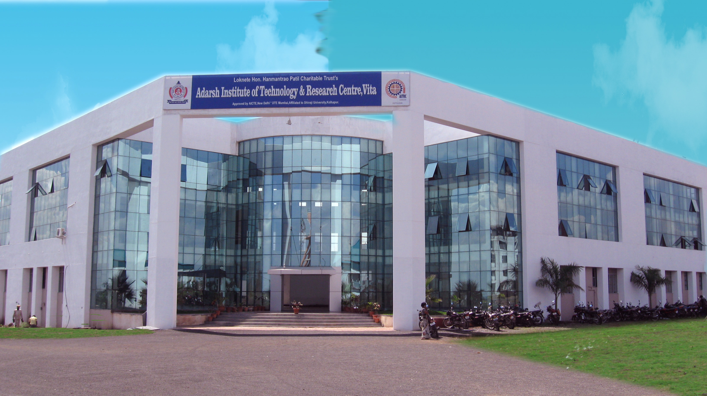**ADARSH INSTITUTE OF TECHNOLOGY AND RESEARCH CENTRE, VITA.**

**Dr. Babasaheb Ambedkar Technological University, Lonere**

**2023-2024**